# Our Company, Our Vision

In this chapter, I will talk about the role I played to aid with the development and production of Ant-Forensics solutions and the products we offer. I will discuss the research I have found and how that research will play a key role to the development of Anti Forensic solutions

The team behind Anti Forensic solutions have the purpose and determination to bring the knowledge involved behind forensic computer defence to the everyday computer user. We want to bring the ability to defend yourself to the public. Our company wants to fill the current gap we have found and bring an industry standard market to this area of computing. Anti Forensic solutions have the goal and determination to be a company that will provide the everyday computer user with the ability and knowledge to defend themselves from vulnerabilities and potential privacy breeches that lay within their digital footprint, most of which they don’t know exist.

# Market Evaluation

Before completing the development of this product, research had been conducted on our products background area, by the research director Asahd. Through research, we had found that anti forensic tools were out there available online available for public download by anyone. The problem with this was that we had found that the majority of users where confused on how to use different tools as they were requesting guides on how they work and some users where asking what tools can be used for tasks that they need completing. We had found that online forum boards where the primary source of providing information for people to access and find these tools. In addition to this we found that these tools where being used and requested daily, but the accessibility to them and the usage of them was limited to the people with knowledge on working with the tools as most forum boards are tight knit communities. We had found that the majority of users and potential customers where people sticking to forum boards asking for tips and tricks on what tools they could use for tasks we can offer solutions too, for example people would ask on how they could recover deleted files.

(<http://www.tomshardware.co.uk/forum/215655-46-where-deleted-file-network-share-drive>)

With this information, we had recognised that there was a gap in the market surrounding the area of Anti Forensic tools, so as a company we made the decision to capitalize on this gap. We had realised that we could fill and bring a market to an area which has been overlooked and avoided.

We had found that different tools were available to the public for purchase or for open source downloads, however they were scattered around on different sites, some foreign sites and a lot didn’t provide that trustworthy and professional feel. They were hard to find and presented in a format that was un-useable to the average consumer requiring a decent level of technical understanding, for example the tool on windows called jhead, which allows a person to access exif data in an image. The tool only works via the command prompt and provides no GUI making it difficult for most to use.

There are products available which group tools together but they do not meet certain criteria and offer a professional experience to a customer like we want to offer to the general public. For example the hiren boot cd, this is a product that offers different utilities, but they are out of date and is provided on a CD. They also don’t allow direct downloads from their site, they link you to other sites, some of which bring up a potential virus threat.

Based on further research, we had predicted that our product would fill this gap and create a market which offers a unique variety of tool packages that would be available to the general consumer and thus enable a new found edge to one’s personal privacy requirements. We took the benefits of open source tools already available for use, we then handpicked each tool to complete the package description.

We looked at the current negatives in the market, such as people implementing viruses into tools. Through this, we had made our product stronger by thoroughly searching each tool. In addition to this, extensive research was conducted in order to determine the best tools that could be grouped up that were not already available as a package or in a usable format to the general public. From this, our product had been created.

# Marketing Strategy

Our marketing strategy will consist of us providing our clients with the reassurance that we will be able to fulfil their needs and support them with our guides and tutorials. We are keen on directing a user to the correct product they will require based on the needs they have. With our company, Anti Forensic solutions being one of the first in this market area, we have the intentions of undertaking wide-ranging advertising techniques. Due to the nature of the product, we will mainly focus on online advertising creating a name for ourselves within the online communities on forum boards etc. We will also incorporate traditional advertising methods, keeping it within the monthly budget.

With the marketing strategy devised, we were able to decide on how we intended to sell our product and create an image of it. We decided to package the tools and distribute them on to usb sticks for reasons verified by research, feasibility, and cost efficiency. We had looked at similar past products and the way different ones had been completed and distributed. Some products had been sold on CD’s and others where available for direct download. We decided not to pursue any of these methods for distribution as CD’S have become obsolete since a lot of devices don’t have cd drives any more. Also they aren’t as efficient when being used in a live environment. Although direct downloads are a faster, easier and more cost efficient method of packing a product, they aren’t as efficient for use and come with a great safety risk. There would be risks with offering direct downloads for our product, other websites could acquire the packages and re distribute them, but with malicious intent. USB sticks seemed like the most efficient method of distributing our packages because it would make them more efficient to use and offer a better sense of security for consumers as they would have knowledge that the product is coming from a trustworthy company.

# Advertising

Playing a crucial role to the development and growth of our product, advertising will be something that we will have to take a great planned approach to. When developing and creating our product, one of the most important aspects of advertising is planning on how we will market the product to our customers.

We completed extensive research on methods we believed could be most beneficial for getting our product out there and established. After numerous group decisions, based on evidence provided by the marketing and research director. Anti Forensic solutions decided to focus on taking the social media approach for marketing our product and spending the majority of the budget there, with the exceptions of some traditional advertisements such as a billboard and a newspaper advert.

We found that with our product being aimed mostly at the more technically literate users, they are more likely to discover the product if it is advertised online on sites such as Facebook, Twitter, Instagram and different websites. Alongside this, we are using a traditional marketing method which is using a billboard. This is a useful method since we will be able to advertise to the general public.

As advertisements are a big factor to the sales for our product, a £4000 monthly budget has been allocated for advertising.

## Website

Just like the majority of companies in current times, we will feature a website as a part of our business. Developed by our web department, which is a sub project being led by Adam Morrison. The web site will be used to present what the company stands for and the services we offer; it will include in depth descriptions of all available packages for our customers to read. For Anti Forensic solutions, the website will play a bigger part than just advertising our product, as we will also include written and video guides on how to use each individual tool which is part of the service we offer.

## Social media – Facebook, Google+, Instagram, Forum boards, YouTube

Due to the nature of our product, building an online presence is very ideal as our company intends to have a lot of online customers. One of the ways in which we intend to build this online presence is through social media as social media users are the type of people Anti Forensic solutions wants to bring knowledge too. With the nature of how social media works, we will be to spread our product making It reach a lot of potential customers. All of the social media services we intent to use are free except Facebook. With Facebook, a company has the option to make their page a sponsored advertisement.

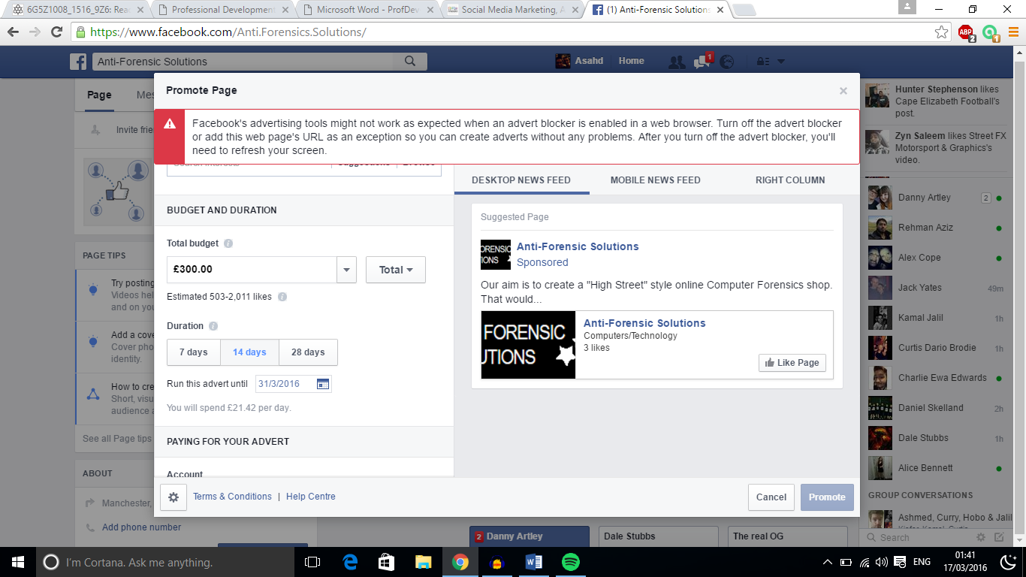

Figure

If you look at [Figure 1], you will be able to see that if we were to spend £300, we would be able to reach an estimated amount of 503 – 2011 people over a 14-day period. With Facebook we, as a new company will have the option to display our product to people that are interested in viewing new technology and people interested in forensic computing.

## Tech bloggers

Another method of advertising which we believe will be greatly beneficial to our company will be to offer the chance for bloggers and technology reviewers a chance to get a hands on experience of what our product offers. after this, they will have the chance to r review the product on their site. This is greatly beneficial to both parties as it allows us to reach their fan base, while giving them a chance to breach a new market for reviewing.

## Web banners

An additional method to online advertising which Anti Forensic solutions will peruse is using online web banners. This form of advertising will start with a 3-month trial, the purpose of this is to value its electiveness based on the success rate. We will aim to place these banners on website which are based on similar technology to ours, for example for boards regarding computer question’s, computer stores and websites that are just generally based on technology. After researching different companies that offer web banner advertising services, Anti forensics solutions has decided to use Google AdSense, the way in which this works is by paying a bided amount of £0.50 - £1 per click we will get on one of our banner. You set a company budget, so anti forensics solutions have decided to allocate £1000 a month to advertise like this. Google AdSense will place our web banner adverts on sites that are technology and forum board related.

## Billboard and newspaper

As well as aiming to generate a big online presence, Anti forensics solutions still intends to pursue some traditional advertising methods such as a billboard and a newspaper. Weill place an advert on a billboard placed outside the Piccadilly train station, we have decided to use this billboard because we believe that it will be seen by a lot of people as Manchester Piccadilly is one of the business train stations in the UK.

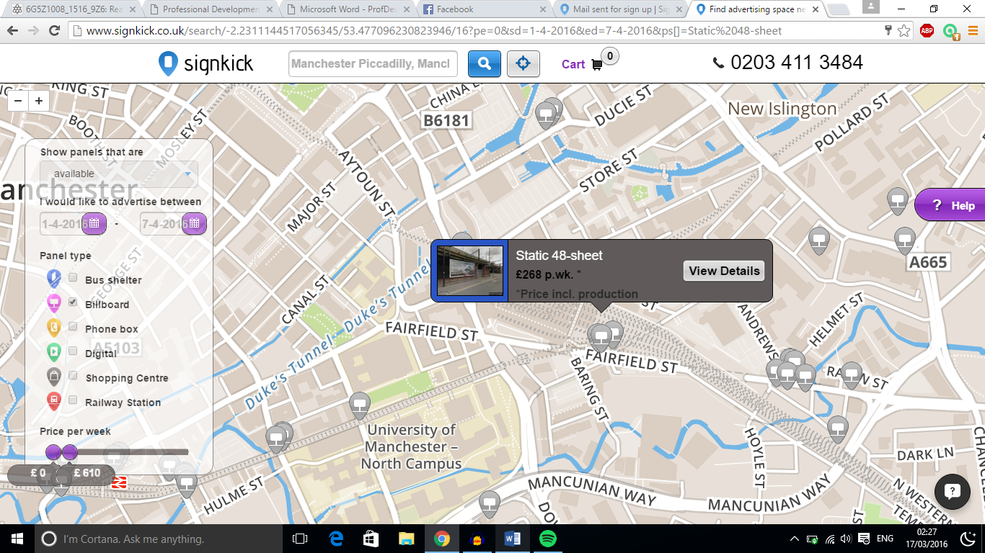

Figure

If you look at [Figure 2], you will be able to see billboards that are available for advertising on through signkick. The location I have selected in [Figure 2], is placed directly outside the Piccadilly train station and it will cost us £268 for the first week of advertising on this billboard. In this cost, printing and labour is included.

Another method of traditional advertising, which has an estimated number of 5,178,00 readers daily is by using a Newspaper slot, more specifically a slot on The Sun newspaper. Advertising on a small spot here, will cost £77 a day. On launch week, we plan on advertising every 2 days for 7 days. This will cost us £539.

|  |  |  |  |  |
| --- | --- | --- | --- | --- |
| Form of advert | Total cost of advert | Monthly Budget | Remaining budget | Total spend |
| Facebook | £300 | £4000 | £3700 | £300 |
| Google AdSense | £1000 | £4000 | £2700 | £1300 |
| Billboard | £268 | £4000 | £2432 | £1568 |
| Newspaper | £539 | £4000 | £1893 | £2107 |
|  |  |  |  | £2107 |

Currently we are left with £2107 of the monthly budget for advertising, as time goes on more money will be spent on advertisements that prove to be useful.

# Launch Event

## Introduction to the event

As with a lot of newly released products, Anti Forensic solutions had decided to follow the global trend and host a launch event which will showcase our product. The aim of this launch event will be to promote our company and the products we will be creating and selling. The event will be aimed for the end of third term of education times, as that will be when a lot of people are free and students will be stress free and able to attend. We will host the launch event as an open event, where anyone will be able to attend with or without an invite.

## Why are we having a launch event?

The purpose of this event will be to showcase our product and prove to the customers that there is a need for Anti Forensic solutions to tackle issues they more than likely didn’t even know existed. To prove to the customers that what our company will offer is real, we will hold live demonstration’s on machines setup with scenarios in which our devices are created for. On top of this, we will allow people to bring in their own laptops for us to show that our product works and that there is a need for it.

The launch event will also serve a purpose of allowing customers to meet the team behind the product and allow us to build a customer relationship.

## Target audience

At our launch event, we will initially target our invites towards local businesses and companies that could benefit from using our product and selling our product. We will invite local stores that sell different types of technology such as mobile phone repair stores, computer repair store’s and local big chain business such as inviting the manager of Manchester’s curry’s & PC world. We will then target smaller audiences such as individual users, these will be people of the general public. We will target adverts to these people through social media pages, and inviting forum board communities.

An additional note for the target audience, due to the location of the launch event (The university of Manchester) We are hoping that students and staff will also attend our open event.

## Agenda

When hosting a launch event, it is crucial to have a scheduled event. Each task must be completed down to the minute, as well as this each member must present themselves with a professional manner as this will represent the company.

10:00am – 10:30am – Arrival – Upon the arrival of our guests, we will stand near the entrance and around the venue having informal greetings with visitors and answering any questions they may have about the day. Tea, coffee and biscuits will be available.

10:30am – 11:00am - Welcome and introductions to the company – This speech will be given by the team leader, he will talk about the team member’s backgrounds and what drove us to creating this product etc.

11:00am– 12:00pm – Introduction to the product- This is a speech to be given by the deputy leader, he will talk about the product and the power behind it

12:00pm – 1:00pm – Lunch – Buffet style

1:00pm – 1:30pm – Marketing will present his research found supporting the development of the product and will explain his role within the company

1:30pm – 2:00pm - Finance will present the costing of the product, projected profits and explain his role within the company

2:00pm – 3:00pm – A live demonstration of each package being used

3:00pm – 3:30pm – Live demonstration’s will be performed on the devise of visitors

3:30pm – 4:00pm – closing speech by the team leader and a summary of the event

4:00pm – 4:20pm – Questions and answers

4:00pm – 6:00pm – Informal chats till the venue hire time ends, talk about potential sales.

## Location

Anti Forensic solution has decided to use university place as its location for the launch event. This is a hall located inside the university of Manchester. This will be an ideal location for Anti forensics solutions and the customers as their will be a lot of support from the staff members regarding the location and technical issues. The location is ideal as it is reachable via public transport.

The venue comes included with standard equipment such as a data projector, pa, projection screen, network point and presenting computer, all of which are included in the booking price. The venue can house up to 1000 people.

## Launch event costs

|  |  |  |  |
| --- | --- | --- | --- |
| Item | Total cost of item | Budget | Remaining budget |
| Venue – theatre A | £695 | £20,000 | £19,305 |
| Tea/coffe and biscuites | £2.34 per head | £20,000 | N/A |
| Buffet lunch | £8.50 per head | £20,000 | N/A |

# swot analysis

|  |  |
| --- | --- |
| Strengths | Weaknesses |
| Strong market potential | Software is open source |
| Large market opportunities | Laws can always change |
| New updates and software will always be available as technology advances` | People could request their software to be removed from our product |
|  |  |
| Opportunities | Threats |
| The potential of expanding the company worldwide | Our software and idea can be stolen |
| Global interest as product isn’t region locked |  |
| Potentially, every computer user would have a need for us so a large customer base chance |  |

# Looking ahead

As technology advances on a daily basis, the way in which our product works could always change. The members at anti forensics solutions will always be on top of current technology changes and as the marketing and research director, it will be my job to keep a constant eye on the market looking out for competitors and changes within the laws that could affect us.

# In the next chapter

In the next chapter, my college Andrew Slater will discuss the tools used, how they work and the choices behind selecting them.